Changing Culture
An Action Plan

Dan Ward

If I wear a big purple cowboy hat to work every day, that’s just Dan being quirky. If everyone in a particular organization wore big purple cowboy hats, we might say the organization has a Purple Hat Culture. And if only a small group within the organization wore big purple cowboy hats, that would be a purple hat sub-culture.

Culture is about more than headgear, of course. Culture refers to a broad set of shared behaviors, symbols, standards, assumptions, and beliefs. While senior leaders play a large role in establishing these cultural elements, culture is primarily expressed by the company’s workforce. Thus, any attempt to change a company’s culture must primarily focus on the workforce itself.

This paper presents a set of specific actions a company or organization can take to change its culture. These actions are oriented around the “influence channels” diagram below. These four channels play a large role in defining how an organization’s members see the world, make decisions, and solve problems. Presenting a consistent signal through all four channels increases the likelihood of the change being adopted, while conflicting signals reduce the likelihood.

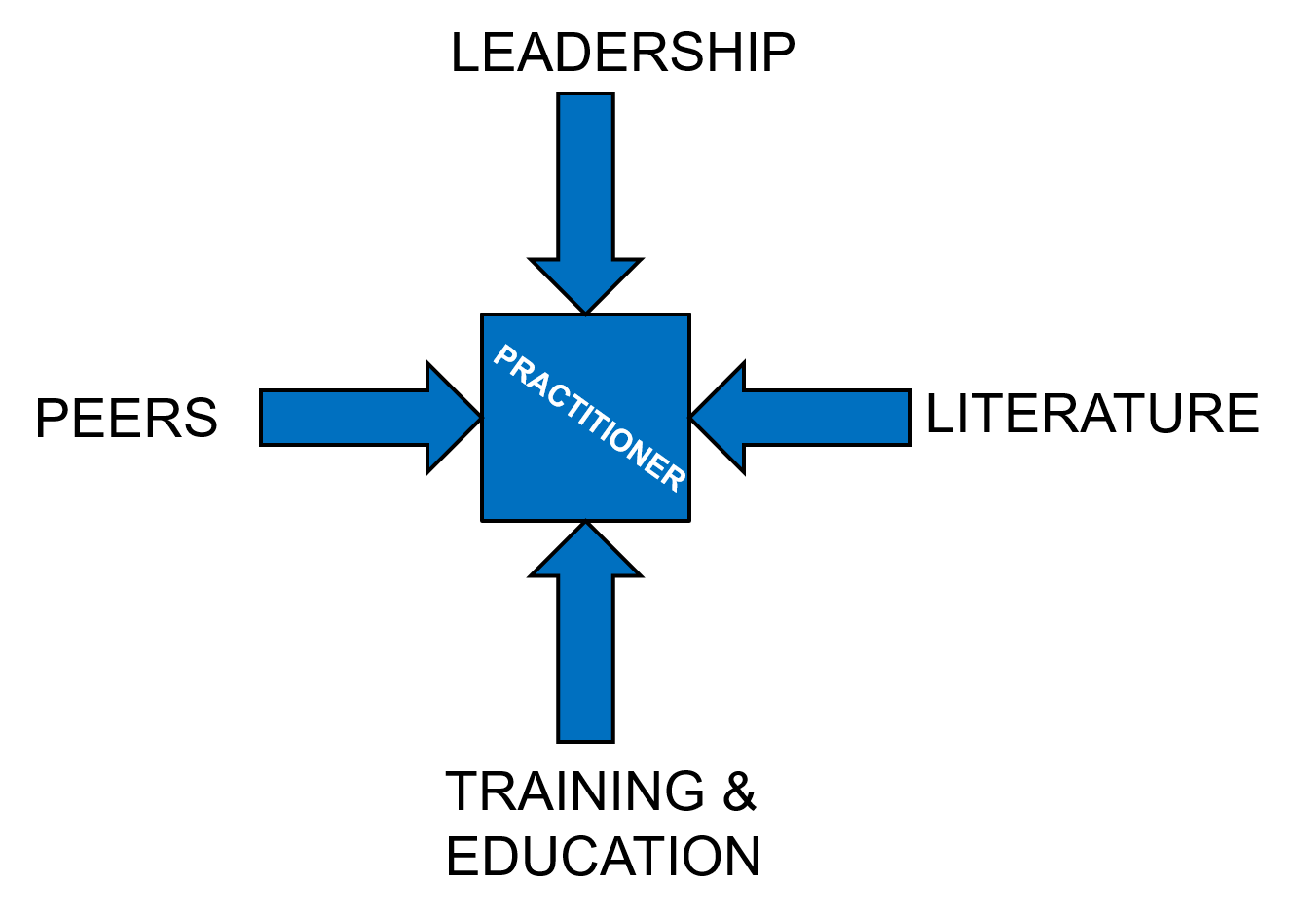

THE PRACTITIONERS
The practitioner box in the center of the diagram represents the workforce. The first step in a culture change plan is to identify the members of the workforce and to describe their goals, behaviors, and priorities. One way to do this is by creating a Persona or collection of Personas, which are typically based on conversations with real people. These descriptions of user archetypes can provide insight into the current culture.
ACTION: Create personas to describe workforce members.

THE LEADERSHIP CHANNEL: Messages & Metrics
Leaders contribute to culture change in many direct ways, including the following:

Messages – what do leaders say (or not say)
Metrics – what gets measured, reported, paid attention to, used, and acted upon?
Incentives – promotions, rewards, recognition, encouragements
Funding – where do leaders allocate financial resources
Enablers – other, non-financial resources, to include permissions and waivers as well as facilities and processes.

The Leader’s actions can be described in the four steps shown below.

ACTION:
- Define It: Identify the small set of specific principles, concepts, and values that will define the core of the desired culture.
- Announce It: Be persistent and consistent in getting the word out, through every available channel, continually reinforcing the core message. Connect it to as many aspects of the company’s activities as possible.
- Track It: Introduce metrics and incentives to reinforce the desired culture. Metrics might include brief workforce surveys of attitudes and behavior. Existing incentives can be directed towards culture-change activities, and new incentives created.
- Enable It: Identify opportunities to provide incentives and other support to encourage the culture as it develops.

THE PEER NETWORK CHANNEL: Seek & Support
Culture change requires significant involvement at the grassroots-level. Leaders should therefore make a concerted effort to seek, support, and celebrate examples where the desired culture already exists. Identify the individuals, groups, departments, and divisions that already demonstrate the preferred culture, then reach out to them as directly as possible. Confirm to the members of these groups that they are on the right track. Publicly highlight their stories to show “what right looks like.”

Showing that the desired culture already exists in the organization helps reduce resistance to change and disarms skeptics who try to assert that the desired culture would not work in the organization.

Invite these groups to become active, deliberate contributors to the culture change effort. Meet with group members, explain the type of culture the organization seeks to establish, and challenge them to view themselves as culture change agents. Ask them to engage in shaping the future culture. Provide public recognition and rewards for their efforts.

The Peer Network channel also includes entities outside of the organization. Leadership should look to external entities (competitors, partners, etc) to discover effective culture change practices and to establish collaborative relationships. This is particularly important to do when customers are also working to bring similar change to their cultures. Leaders may want to work with partners and customers to help draft and implement their own culture change plans, to foster greater alignment between them.

ACTION: Identify existing networks and their leaders. Meet with them to discuss their interest and ability to contribute to culture change.

THE LITERATURE CHANNEL: Read & Write
Every significant culture change has a piece of literature at its core. Examples include Tom Peters’ In Search of Excellence, The Agile Manifesto and Eric Ries’ book The Lean Startup. Each of these documents played a critical role in fostering large-scale culture change across a wide swath of business and industry.

A written document provides clarity and cohesion, a shared sense of direction, and a common set of vocabulary, symbols, and terms. It serves as a rallying point and helps new team members understand the principles, practices, and objectives of the cultural shift. If leaders want to foster a specific type of culture, a written statement is essential. As noted in the Peer Networks section, leadership may wish to collaborate with customers and partners on this document.

This document should be brief, sharable, and engaging. It should be specific and aspirational. It should be something readers can identify with and take ownership of, as well as something they can build on. The document should be the start of a conversation, not the end of one, and leadership should invite the rest of the organization to engage and respond.

Influential business documents like these tend to be rooted in existing writings which are already familiar and well-regarded by the target audience. The source material provides the foundation for the ideas and principles being expressed. So when drafting a statement about the desired culture, they should incorporate references to other related writings on the topic.

Finally, influential documents tend to inspire additional writings which further explore various facets of the new culture. Thus, along with publishing and distributing a document, leaders should invite the workforce to further contribute to the literature.

ACTION: Write a brief “manifesto” describing the desired culture. Publicize it throughout the company. Invite the workforce to continue the conversation in writing.

THE TRAINING AND EDUCATION CHANNEL: Teach & Learn
Culture is heavily influenced by the methods and tools we use; learning to use new tools generally requires training. This training should include informal OJT and academic classroom sessions. Internal “school houses” provides a mechanism for more formal training and education. Since the outlets already exist, what remains is to introduce specific training content that is aligned with the desired culture.

This training can introduce new processes and procedures as well as new principles and concepts. The first step is to identify the types of learning and training that might reinforce the desired culture, then create opportunities for personnel to receive that training.

As with the Literature channel, there is an opportunity to simultaneously use existing content and to commission new content. Specifically, leadership should commission a series of courses and training events that reinforce the culture change message and provide the workforce with appropriate tools, principles, and practices.

ACTION: Identify existing training (in-house and external) that supports the desired culture. Identify gaps to be filled and commission additional training to be developed and delivered. Encourage workforce to participate in training.

SUMMARY
Culture change takes time and is never easy. It requires consistent effort from a significant portion of the organization. Fortunately, there are ways to direct and accelerate the change. The four influence channels described in this paper can serve as catalysts to nudge culture in a desired direction. By introducing a consistent, mutually-reinforcing message into each of these four channels, we can increase the likelihood of the culture changing in a meaningful way over the long-term.

This diagram first appeared in Changing Acquisition Culture: What & How, Dan Ward, Center for National Policy, 2013.

